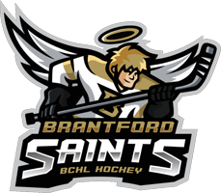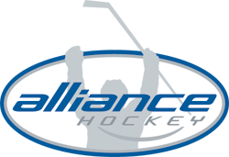
2018 IP Festival – Hosted by Brantford Church Hockey League
April 7th and 8th, 2018
Festival Rules & Game Format
The objective of the Festival is FUN! This festival welcomes players of all skill levels – however it should be noted that this is NOT a Select Tournament. Participating teams should be comprised of players of varying skills levels.

Rosters & Travel Permits
Player rosters must be submitted to BCHL Hockey in advance of the Festival. Please email rosters and travel permits to registrar@bchl.net. Please ensure that your clearly state your association and team name in the email. In order to maximize participation, we are encouraging associations to send a team comprised of 12-15 skaters and 1 goalie (3 lines of 4 or 5 skaters). You will be permitted to send Alternate Players (AP’s) – the only stipulation is that all of your participating players must be on an approved house league roster within your association. Therefore – it is NOT MANDAOTRY that all players play on the same house league team. You are permitted to combine players from 2 or more teams – however once again – this is NOT a Select Tournament.

Game Format
- Games will be scaled to Cross Ice Format.
- Nets will be age/size appropriate (3’ x 4’).
- The ice will be split into 3 zones – Rink 1, Neutral Zone and Rink 2.
- Two games will be played simultaneously on Rink 1 and Rink 2. 4 on 4 or 5 on 5 will be acceptable – and will require agreement from both coaches.
- The Neutral Zone will be used as a primary bench area – for the next line waiting to take to the ice. The arena benches will also be used as a secondary bench for the 3rd line.
- There will be a 2 minute warm up to start each game.
- Period lengths will be 2x18 minutes – with the horn sounding every 2 minutes to denote a line change.
- Each game will be officiated by a referee.
- There will be no penalties called – however the referee at his/her discretion will whistle down play and take away puck possession from infracting team.
- Face off to start each shift, and after each goal scored.
- There will be no score posted, and no game results tracked. There will be no standings for this Festival.
- There will be a 2 minute break in between the two periods.
- Blue light pucks will be used.
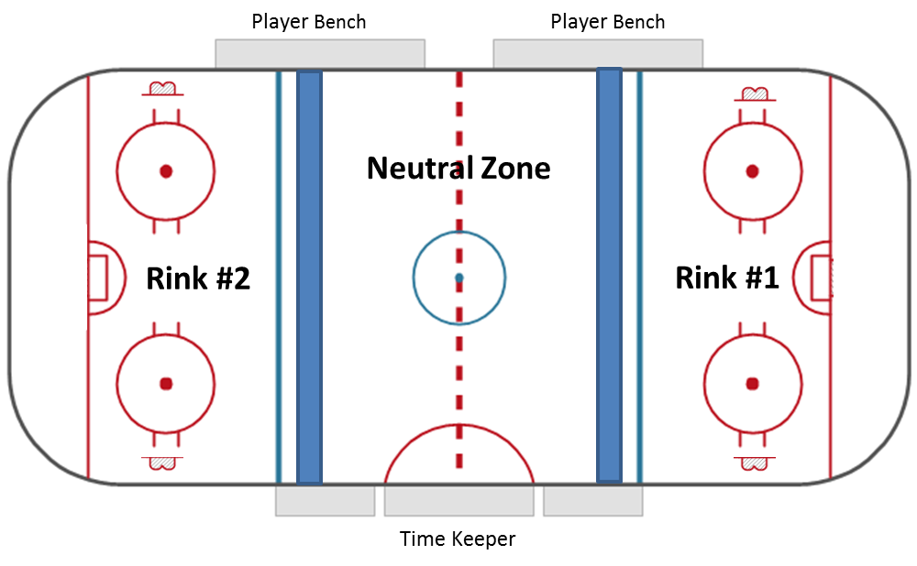
- Assuming each team has 3 lines plus 1 goalie – the first shift, line 1 is playing, line 2 is ready in the neutral zone and line 3 is on the arena bench.
- 2 minute horn sounds – the lines rotate. The line playing moves to the arena bench, the line in the neutral zone takes to the rink and is playing, and the line previously on the bench will now be in the neutral zone. This rotation is to help facilitate line changes quickly.
Coaches are asked to form 3 lines of equal caliber.
** Rules/game format will be subject to change – and all revisions will be communicated to all teams in advance**
Each participant will receive a participation medal and t-shirt. We are planning to hold a Pizza/Pop lunch in the arena auditorium. Full details will be communicated.

If there are any questions, please email George Ziotek (President of BCHL) – gziotek@rogers.com, or call/text 519-761-3118.

